**Documentatie L5 - Proiect cuda**

**Radix sort paralel.**

Ghimpu Lucian Eduard 233 2/2 Holhos Emanuel 233 2/2

**Introducere:**

Radix sort este un algoritm de sortare non-comparativa, care sorteaza datele cu cheile intregi prin gruparea cheilor de catre cifrele individuale care au aceeasi pozitie și o valoare semnificativa.

**Radix sort serial exemplu:**

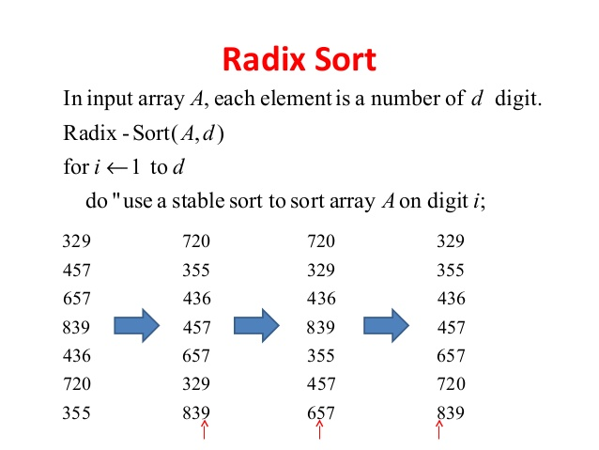

**Radix sort paralel**

**Motivare:**

Daca reducem reprezentarea numerelor in baza 2, in cifre binare, problema se trasforma in una de reducre, calcul de boolene. Astfel ne putem folosii de functii optimizate pe gpu in CUDA cum ar fi:

**__cp =** Count the number of bits that are set to 1 in a 32 bit integer.

**__ballot =** Evaluate predicate for all non-exited threads in mask and return an integer whose Nth bit is set if and only if predicate evaluates to non-zero for the Nth thread of the warp and the Nth thread is active.

**Exemplu** rulare radix sort pe reprezentare binara:

Prima data luam bit-ul 0.

Element # 1 2 3 4

Value: 7 14 4 1

Binary: 0111 1110 0100 0001

bit 0: 1 0 0 1

Impartim biti de 0 apoi de 1.

Element # 2 3 1 4

Value: 14 4 7 1

Binary: 1110 0100 0111 0001

bit 0: 0 0 1 1

Trecem la bit-ul 1.

Element # 3 2 1 4

Value: 4 14 7 1

Binary: 0100 1110 0111 0001

bit 1: 0 1 1 0

Impartim biti de 0 apoi de 1.

Element # 3 4 2 1

Value: 4 1 14 7

Binary: 0100 0001 1110 0111

bit 1: 0 0 1 1

Bit-ul 2.

Element # 3 4 2 1

Value: 4 1 14 7

Binary: 0100 0001 1110 0111

bit 2: 1 0 1 1

Impartim.

Element # 4 3 2 1

Value: 1 4 14 7

Binary: 0001 0100 1110 0111

bit 2: 0 1 1 1

Bit-ul 3.

Element # 4 3 2 1

Value: 1 4 14 7

Binary: 0001 0100 1110 0111

bit 3: 0 0 1 0

Ultima miscare.

Element # 4 3 1 2

Value: 1 4 7 14

Binary: 0001 0100 0111 1110

bit 3: 0 0 0 1

**Informatii masina:**

Device Number: 0

Device name: GeForce GTX 960M

Memory Clock Rate (KHz): 2505000

Memory Bus Width (bits): 128

Peak Memory Bandwidth (GB/s): 80.160000

**Comparare timp Radix Sort Serial vs Radix Sort Paralel**

**X – Numar Elemente**

**Y – Timp in secunde**

**Serial**

**Paralel**

